**Introduction**

This ia an application that can integrate with various health care systems and provide a centralized place for physicians to keep track of their patients. The application is designed to be seemless and easy for the physicians to use. All they have to do is log in and all of their patients will be available to use. The application also provides reporting functionality to track the performance of the physician group.

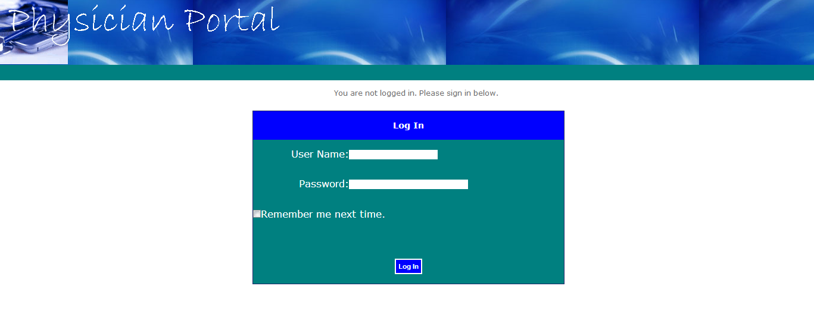

**Staff Level User:**

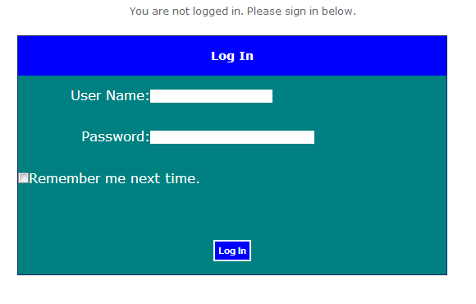

(Figure 1)

An administrator will supply you with login information. Visiting the site will prompt you to enter the supplied username and password to log in. (Figure 1)

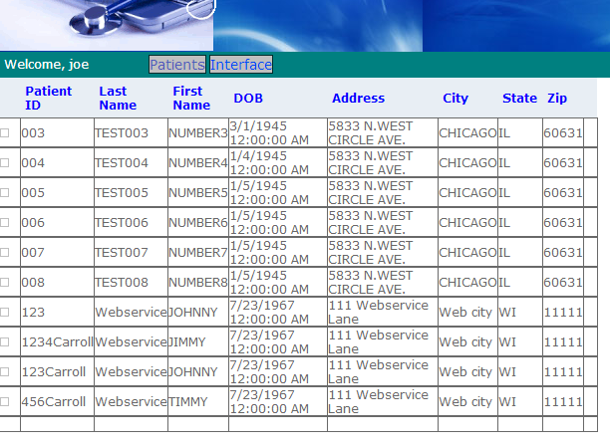

(Figure 2)

As a staff user, you will have access to a patient list and the interface log. The patient list (figure 2) will display all patients that are being seen by physicians in the physician group.

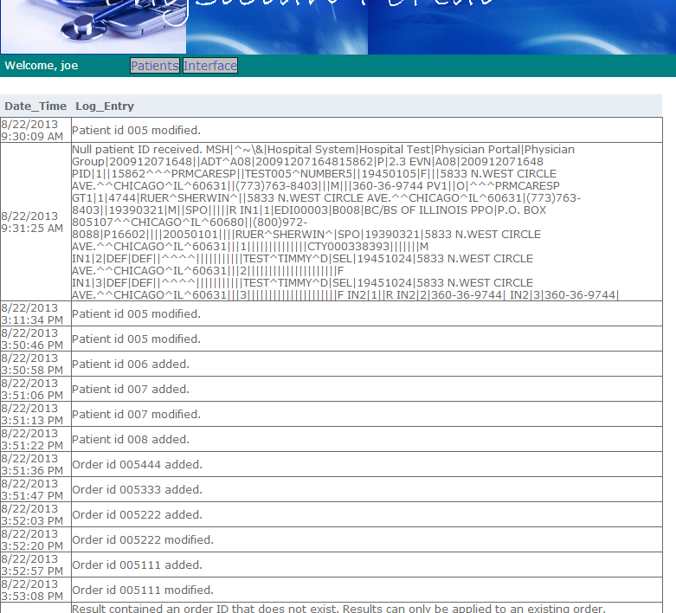

(Figure 3)

The interface log (figure 3) will list all activity that the application has received through the web service interface. If there are problems with an imported message, the error will be written to the interface log along with the raw HL7 transaction so the issue can be fesearched.

**Administrator:**

Administrators will be added to the application on deployment. These accounts have more functionality than the basic user accounts. The administrative user will be able to view the same patient list and interface log as the staff level users. In addition, the administrative user will also have access to the reports and table maintenance pages.

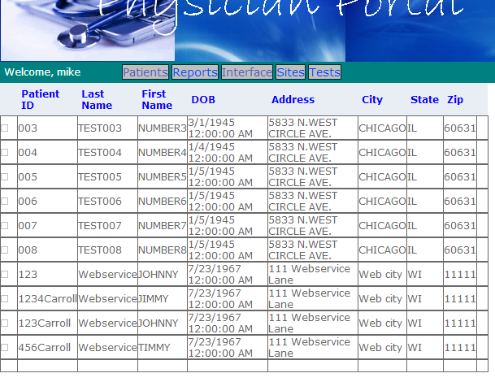

(Figure 4)

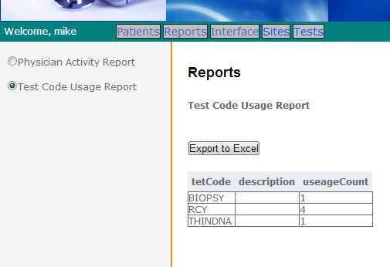

(Figure 5)

The application will come delivered with two reports (figure 5), the Physician Activity Report and the Test Code Uasge Report. Additional reports can be requested from development. Each report can be exported to an Excel formatted file.

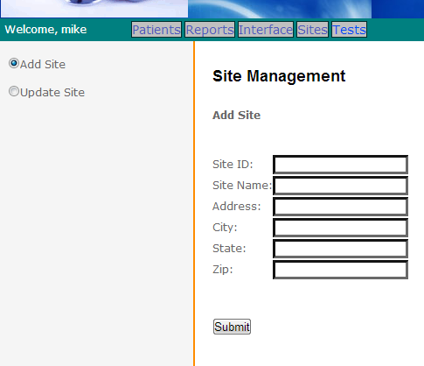

(Figure 6)

Table maintenance can be done from any of the maintenance pages (figure 6). You will have the option to either add a new record to the database or to modify an existing record.

**Physician**

The physician is a specific user level designed to provide the physician with quick and easy access to the information that is most important to them. The physician will have access to the reports page along with a personlized patient list.

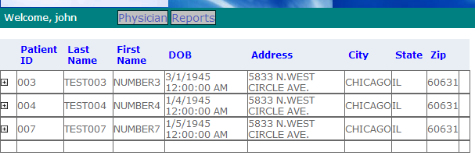

(Figure 7)

Upon logging in, the physician will immediately see all patients that are in his care. The patient list can be expanded to display detailed information for each patient.

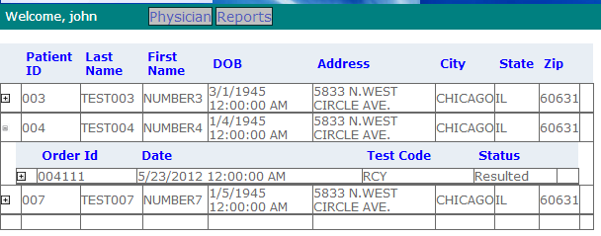

(Figure 8)

Clicking on a row in the patient list will display a list of all orders for that patient (figure 8). If the order does not have a result report available yet the order status will say Pending. If the order does have a result report available to view the order status will say Resulted.

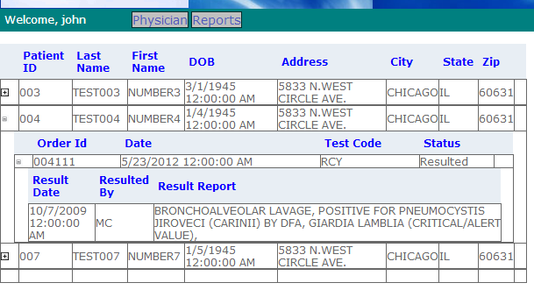

(Figure 9)

Clicking on the row for an order with an order status of resulted will display the result report for that order (figure 9).